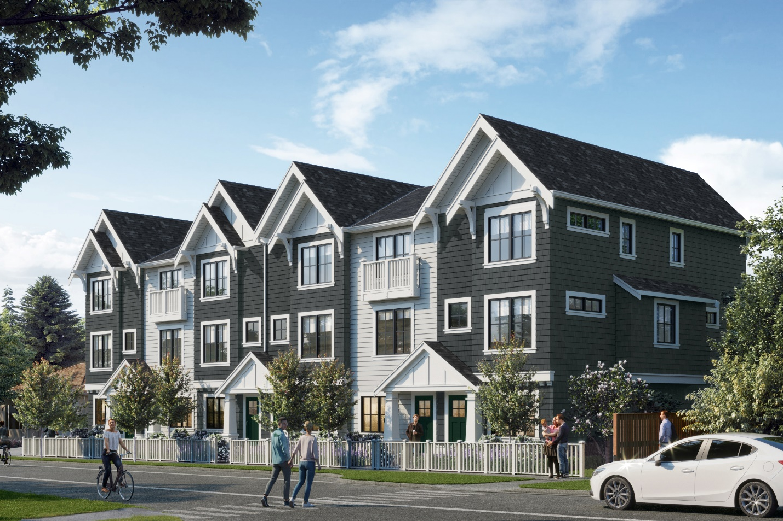
Project Description:

3450 Whittier is envisioned as a traditionally-designed collection of two and three bedroom townhomes, with a mix of single and two car garages. Front entrances are accented by picket fences and patios along the Harriet Road frontage to provide a vibrant, social and established residential feel and character.

Key Statistics
Current Zoning RS6
Proposed Zoning RT5
Proposed Tenure Residential
Total Homes Proposed 23
Resident Parking 32 – 1.4 parking ratio
Building Height 3 Storeys

Community Amenity Contribution

$46,000 or $2,000 per door to be put towards the District of Saanich’s Affordable Housing Trust Fund.

Community Consultation

January 2018 Initial Door-to-Door Introductions
March 2018 Initial meeting and presentation to the MVCCA
June 2018 Door-to-Door re-engagement with preliminary site plan
September 2018 Project update and presentation to the MVCCA
October 2018 Pre-Application Community Open House
December 2018 Application Submitted to the District of Saanich
October 2020 Community mailout re: changes made
November 2020 Email Update to Chair of MVCAA (Rezoning Resubmission)

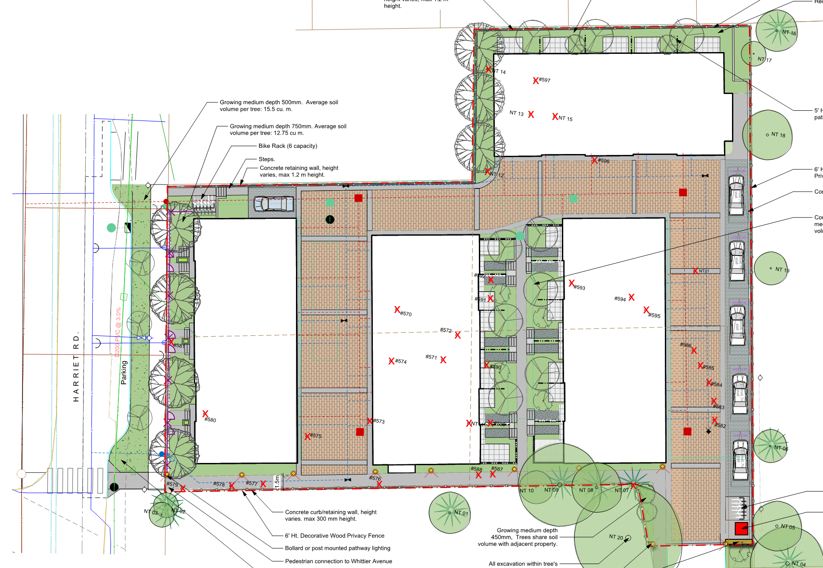
*New Crosswalk
*New Pedestrian connection to Whittier
*New landscape courtyard

