prepared by: Carol Hamill hamill@island.net

Thoughts on the: Official Community Plan (OCP) Phase 1 - Community Survey Questions
survey at: https://www.saanich.ca/EN/main/community/community-planning/official-community-plan-ocp/strategic-ocp-update.html

Question 1) Within Neighbourhood areas, typically we would consider smaller-scale housing forms for infill (e.g., house-plexes, small townhouse projects). What criteria or factors should be considered when assessing how to support these types of smaller-scale infill applications?

The first two questions infer that all “Neighbourhood areas” are essentially the same, without regard for neighbourhood characteristics. Why are there so few applications for construction of these alternative infill types? Saanich Planning must know what criteria are needed to promote the missing middle. What are other cities doing to promote the missing middle?

2) The current OCP supports consideration of low-rise apartments (up to four storeys) in Neighbourhoods. Recent Council direction indicates an openness to six storeys for rental and/or affordable housing within Neighbourhoods. What locations within Neighbourhoods are appropriate for this type of higher-density housing?

The second question assumes that there are locations within Neighbourhoods that should be eligible for six-storey projects. Is it prudent to add six story, luxury rental units to the OCP, just because they are rental? Whatever is allowed by the OCP becomes the expectation of developers and they can reasonably expect that height of project to be approved. If the maximum height is set at four storeys, there is still the option for a developer to argue that their project warrants a bonus of two extra stories. In my experience, whatever you set as the height/density limit in the OCP, becomes the base height for an experienced developer, to use to try to get more height/density.

3) Indicate your level of agreement with including Major Corridors in the OCP for increased residential density along key transit corridors.

The survey reader is being told that “Major Corridors will be added to the OCP” and then asked do they support the Major Corridors concept. My first reaction is, what is the point of the question?, in my opinion, it is the changes to neighbourhoods that will upset residents.

4) Do you support the proposed Major Corridors as identified on the map?
5) What are some key considerations when planning for Secondary Corridors?

As stated, the detailed planning of the Major Corridors will be done, ‘corridor by corridor’. The same process will be needed for the Secondary Corridors. Are there any general characteristics that all corridors share? I assume there are, but that does not diminish the need for local corridor planning. I would argue that planning for secondary corridors can only be done within the neighbourhood context. Do members of the public really have enough information to identify key considerations for all the secondary corridors in Saanich?

Please contact me if you have any questions about this process or the proposed changes. Deadline to complete the survey is Sept. 25.

Carol Hamill

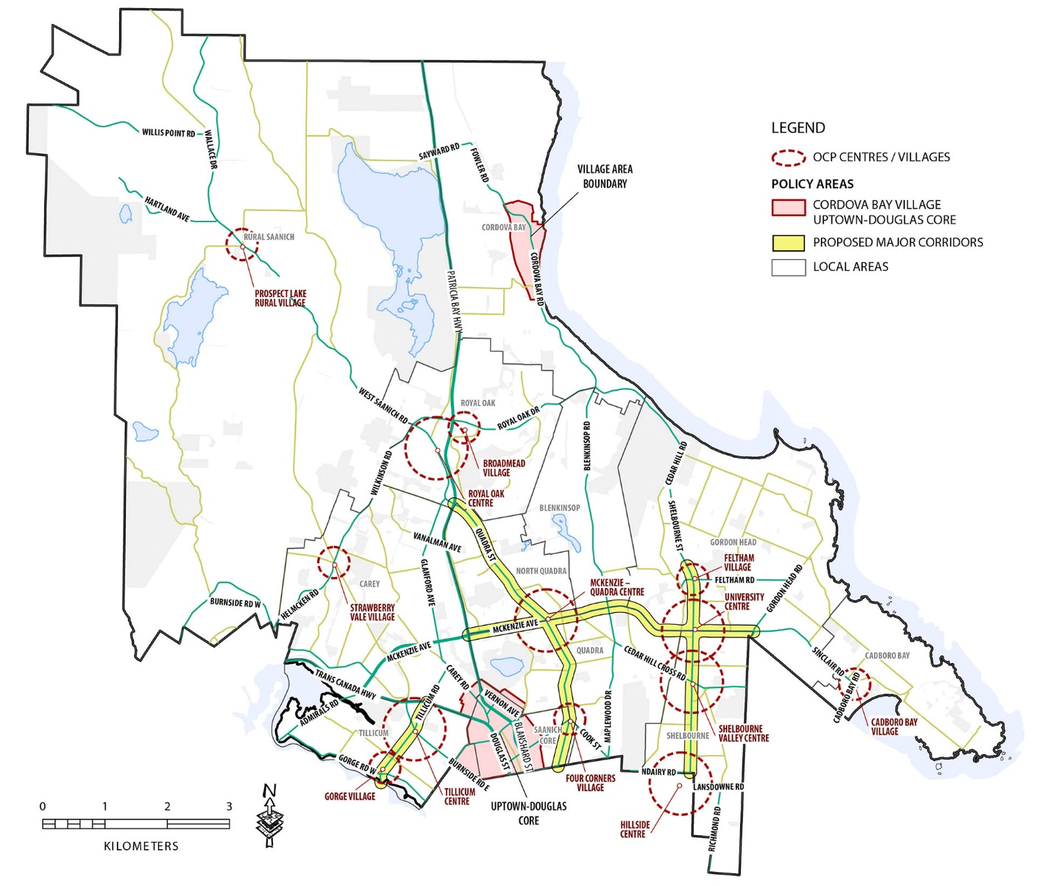

map taken from OCP Phase 1 – Community Survey Summer/Fall 2022

For more information see Q & A page at https://www.saanich.ca/EN/main/community/community-planning/official-community-plan-ocp/strategic-ocp-update/strategic-ocp-update-project-q-a.html

